Department of Civil Engineering
Events 2024-25
Departmental Activity & Events:
- FORUM INSTALLATIONS:

- ACES Forum Installation Ceremony

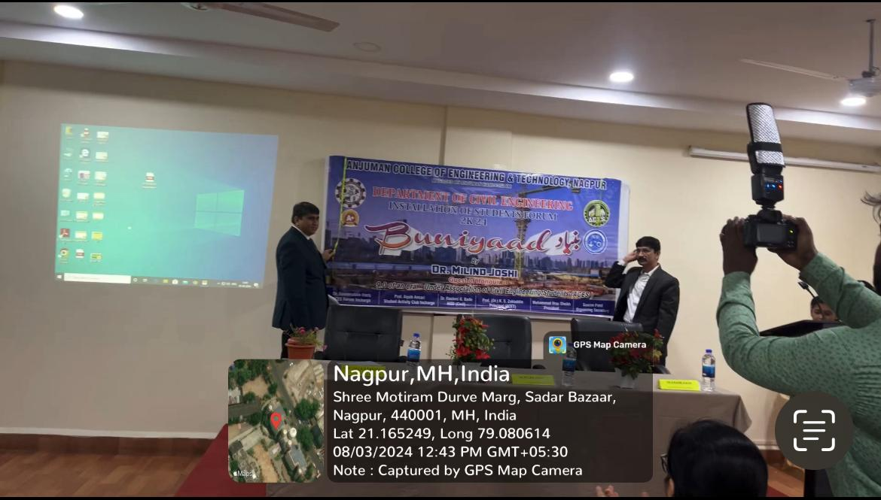
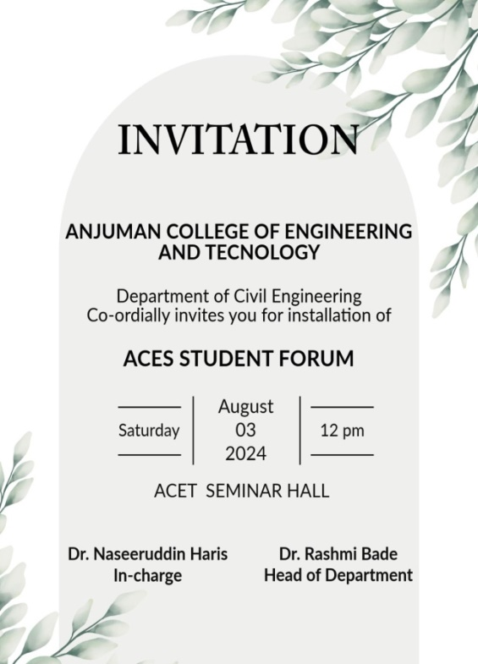

The ACES Forum Installation Ceremony was held on August 3, 2024, organized by the Department of Civil Engineering, ACET, under the distinguished presence of Er. Milind Joshi (Chief Guest)Director of Surya Environtech OPC Pvt. Ltd., Nagpur. and Prof. (Dr.) K.S. Zakiuddin (Principal, ACET).

- STUDENTS CHAPTER INSTALLATIONS:
- ICI Students Chapter Installation Ceremony
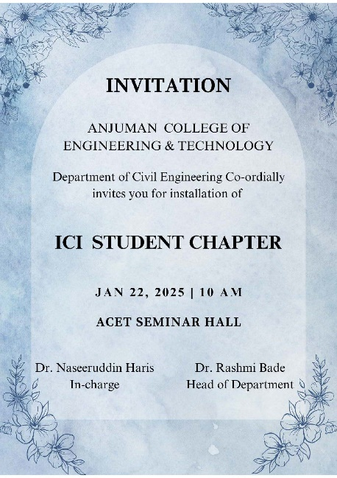
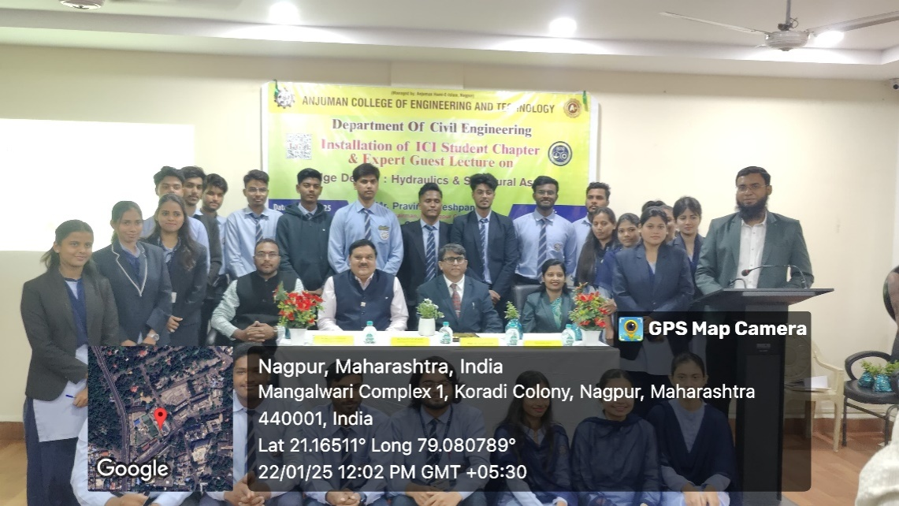

The ICI Students Chapter Installation Ceremony was held on January 22, 2025, organized by the Department of Civil Engineering, ACET, under the distinguished presence of Mr. P. P. Deshpande (Chief Guest)Chairman, ICI Nagpur Centre and Prof. (Dr.) K.S. Zakiuddin (Principal, ACET).

- IWWA Students Chapter Installation Ceremony
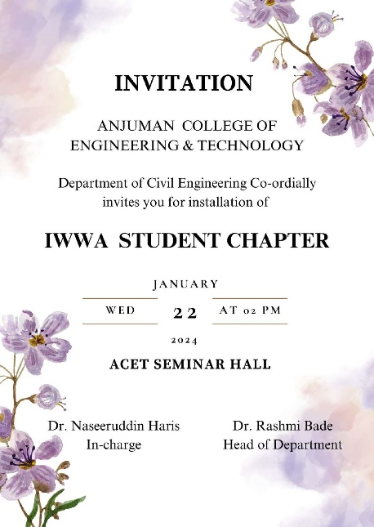
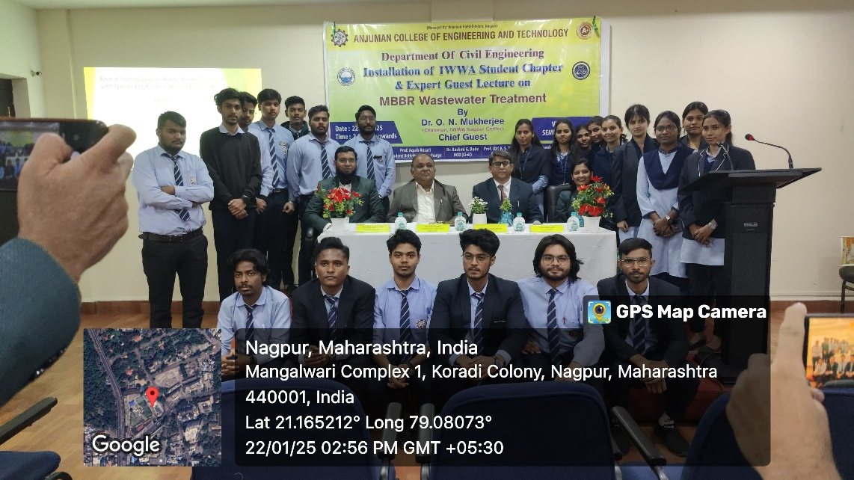

The IWWA Students Chapter Installation Ceremony was held on January 22, 2025, organized by the Department of Civil Engineering, ACET, under the distinguished presence of Dr.O.N. Mukherjee (Chief Guest)Chairman, IWWA Nagpur Centre and Prof. (Dr.) K.S. Zakiuddin (Principal, ACET).

EXPERT LECTURES:

- Expert guest lecture under ACES Student Forum

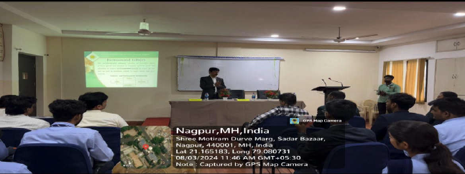

Expert guest lecture on “Environmental Impact” on August 3, 2024, featuring Er. Milind Joshi, Director of Surya Environtech OPC Pvt. Ltd., Nagpur.

- Expert guest lecture under ICI Students Chapter

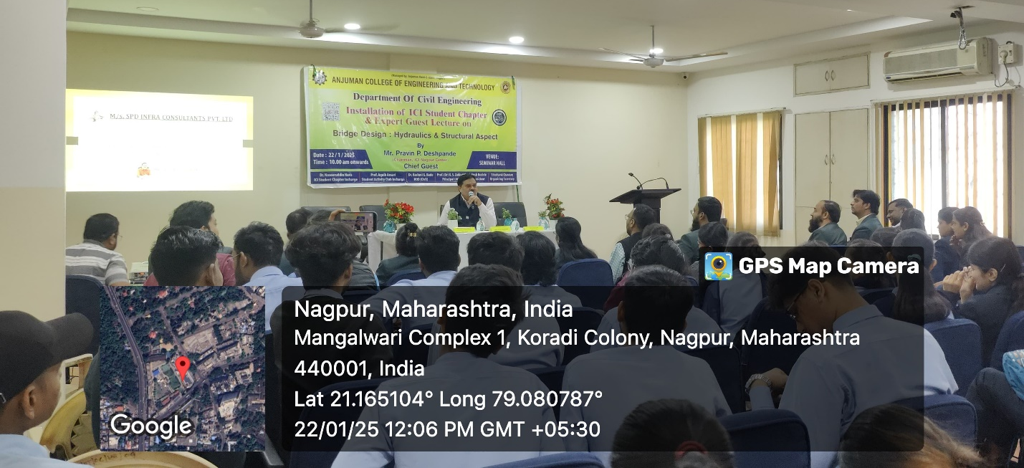Expert guest lecture on “Bridge Design; Hydraulic & Structural Aspect” on January21, 2025, featuring Er. P. P. Deshpande, Chairman, ICI Nagpur Centre, Nagpur.

- Expert guest lecture under IWWA Students Chapter

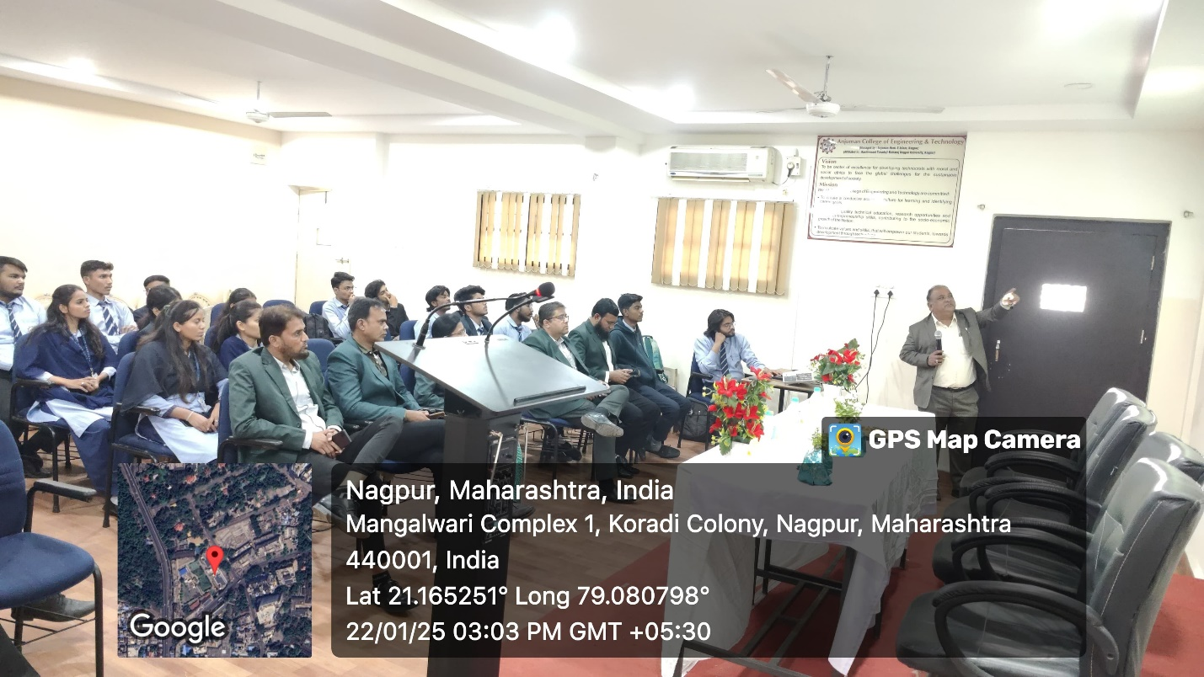
Expert guest lecture on “MBBR; Wastewater Treatment” on January21, 2025, featuring Dr. O. N. Mukherjee, Chairman, IWWA Nagpur Centre, Nagpur.

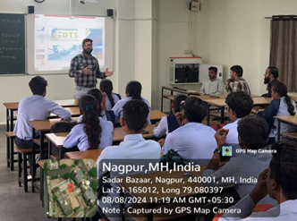
Expert Lecture on" Industrial: BIM Technology by Mr. Dipak BIM Engineer F6 DTS, Nagpur

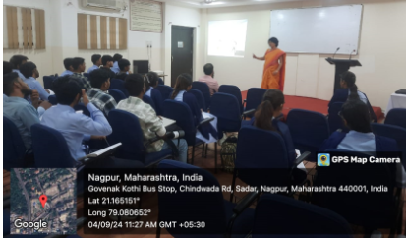
Expert lecture on Solid Mechanics by Dr. K. Kadam (Associate Professor GCE,Nagpur)

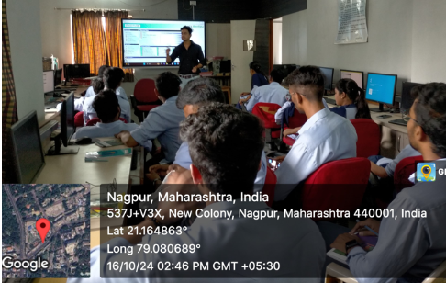
Workshop on Pre-Engineered Building (PEB) by Er. Sagar Doye, Director S.S.D Consultant

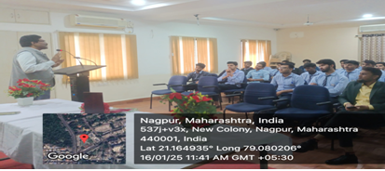

Expert lecture on "Emerging Trends in Water Resources" by Dr. Hitendra Chandewar, Director Hitbhav Engineering, Nagpur
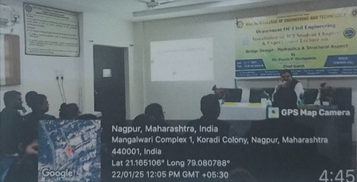
Expert Lecture on Bridge Design Er. P. P Deshpande , Director, SPD Infra Consultant Pvt. Ltd Nagpur

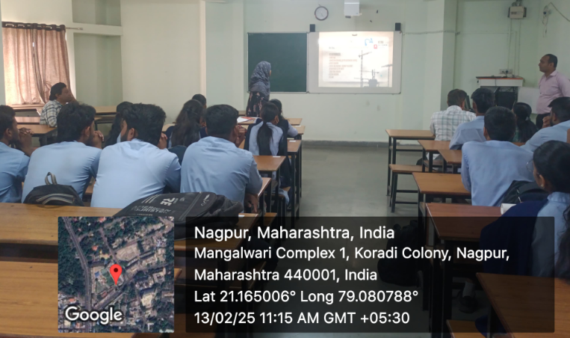
Expert Lecture on Introduction to Argument Reality in Civil Engineering by Mohd Samir Ansari
Manager-Nagpur Region

ALUMNI INTERACTION:

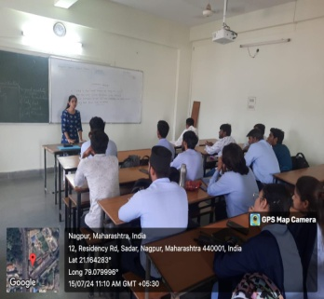
Alumni Interaction with students on “Guidance on career as entrepreneur after Engineering” on 15/07/2024

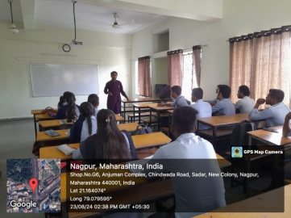
Alumni Interaction with students on “Further Studies after Engineering” on 23-08-2024
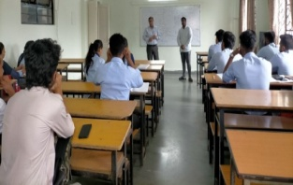
Alumni Interaction with students on “Higher studies, Defense and Government Job” on 30-08-2024

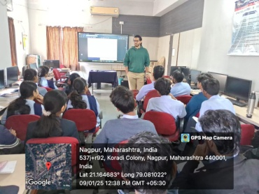
Alumni Interaction with students on “Private Jobs in Civil Engg” on 09/01/2025

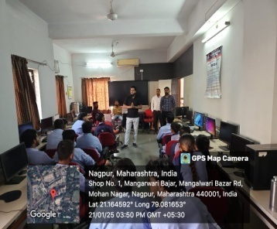
Alumni Interaction with students on “Importance of STAAD PRO Software in Civil Engg”

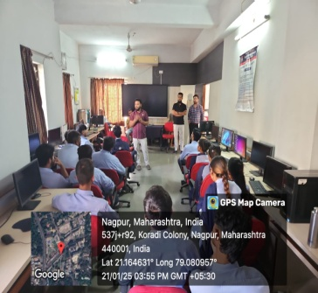
Alumni Interaction with students on “Importance of BIM Software in Civil Engg”
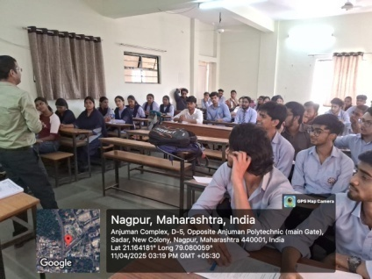
Alumni Interaction with students on “Significance of Pursuing Masters and PhD”

SHORT TERM TRAINING PROGRAMME:
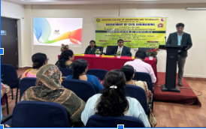
5 days Short Term Training Program “Communication at work place” for faculties
Er.Amandeep Kaur (Coordinator NITTTR Chandhigarh)

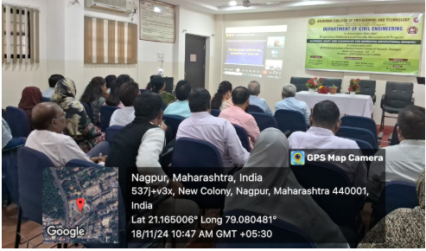
5 days Short Term Training Program "Academic Audit and Leadership for Improving Institutional Ranking” for faculties
Dr.R.K.Wats Coordinator (NITTTR,Chandhigarh)

Technical Training:
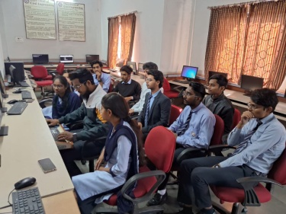
Technical Training on “STAAD PRO” for Second year students of 45 hours

